PROFESSIONAL SOCIETIES

Sl.No. | Professional Societies | Type of Membership
1 | IGS, Coimbatore | Local Chapter
2 | ICI | Institutional Member
3 | Indian Chapter of American Concrete Institute | Institutional Member

ASSOCIATION ACTIVITIES
Civil Engineering Association organize inter college symposium INCEAN and Intra college symposium GEOFEST every year. Encourage the students to participate in various events conducted during symposium. CEA organizes various workshops for civil engineering students from our institutions and other institutions.

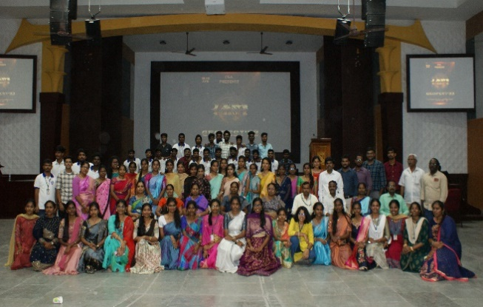
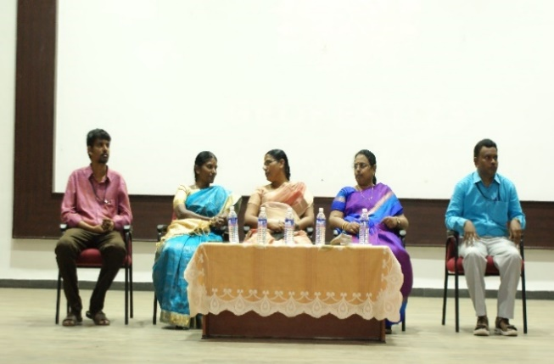
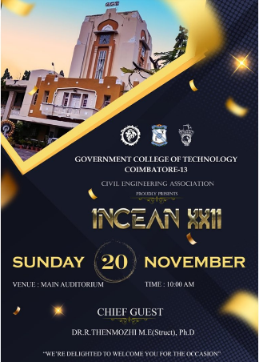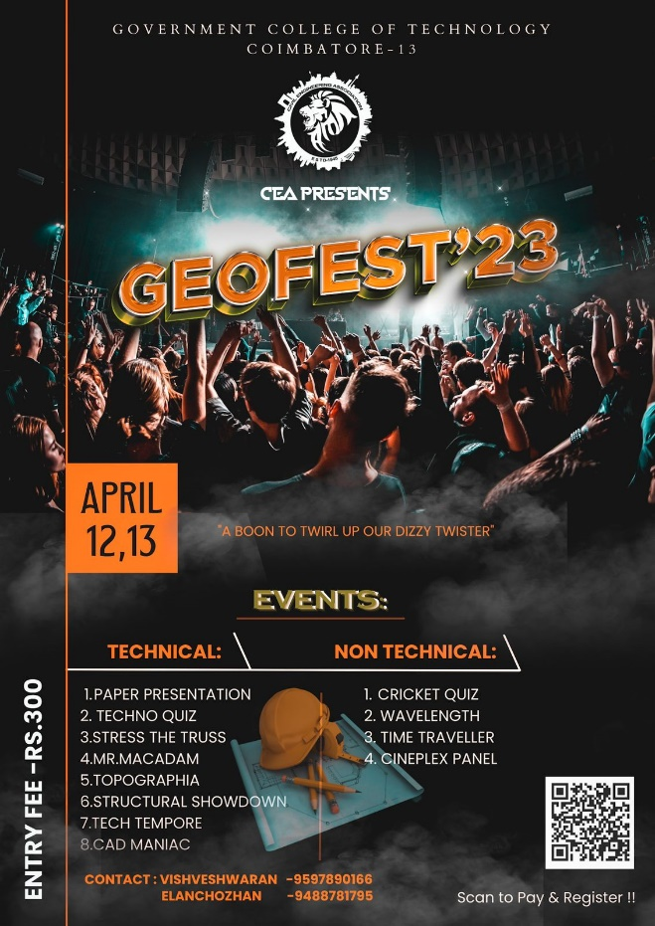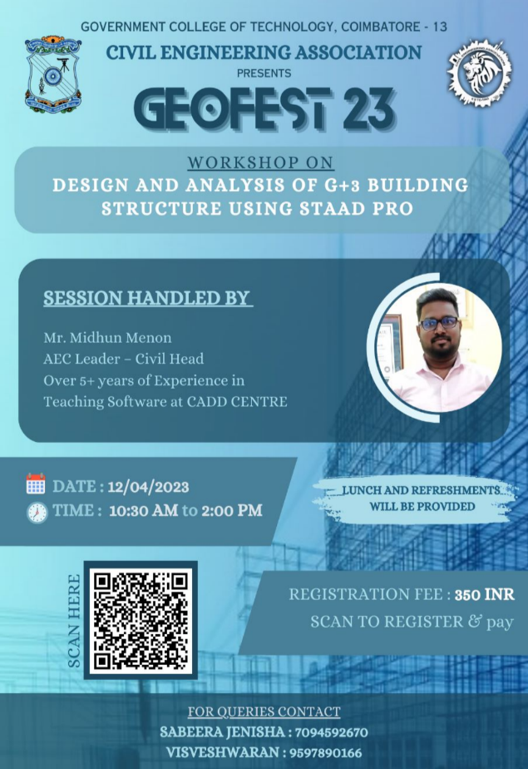

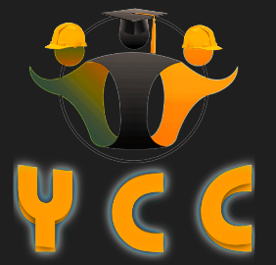
TECHNICAL CLUB – YCC (YELLOW CAP COMMUNITY)
YCC was started by GCT Civil engineering students on 2019. It began an attempt to engage students with industrial pioneers and also to enhance each of their skills in all the
possible ways so that they can reach their destinations in a better path. They
organized lot of workshops and seminars by experts to civil engineering students.
Website: yellowcapcommunity.in

ALUMNI
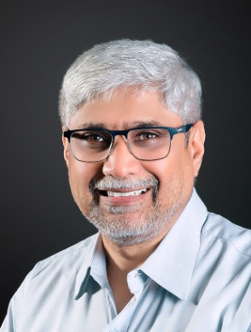 | Dr. Ravindra Gettu  Institute Chair Professor  IIT Madras, Chennai
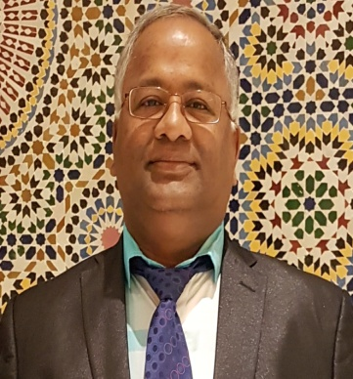 | Dr. S. Neelamani  Senior Research Scientist  Kuwait Institute for Scientific Research(KISR), Kuwait
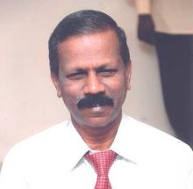 | Dr. R. Sundararajan  Former Principal  GCT, Coimbatore
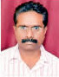 | Dr. A.R. Senthil Kumar  Scientist E  National Institute of Hydrology, Roorkee
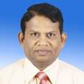 | Er. Sriram Paradesi  Principal Chief Engineer  Indian Railways
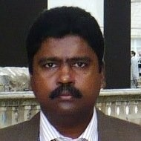 | Dr. S. Parivallal  Senior Scientist  SERC, Chennai
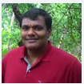 | Er. P. Sriram  Project Director,  Delhi Metro Rail  Corporation (DMRC),  Delhi
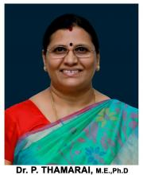 | Dr. P. Thamarai  Retired Principal  GCT, Coimbatore
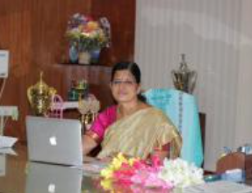 | Dr. G. Vimala Rosaline  Retired Principal  GCE, Salem

