**Government College of Technology; Coimbatore – 641 013.**

**Department of Civil Engineering (Structural Engineering)**

**STRENGTH OF MATERIALS LABORATORY**

1. Computerised Universal Testing Machine - 100 T
2. Digital compression testing machine - 300 T
3. Self straining loading frame – 50 T
4. Brinell hardness testing machine
5. Rockwell hardness testing machine
6. Torsion testing machine – 200kgm
7. Pendulum Impact Testing Machine
8. Hydraulically Operated Universal Testing Machine – 50,000 lbs
9. Vickers Hardness Testing Machine
10. Wood testing machine
11. Longitudinal compressometer
12. Length compartor apparatus
13. Lateral extensometer
14. Digital flexure testing machine

**CONCRETE LABORATORY**

1. Concrete permeability apparatus (As per IS Std)
2. Concrete impermeability apparatus (As per DIN Std)
3. Accelerated curing tank
4. Concrete core cutter
5. Pan mixer
6. Self compacting concrete test apparatus
7. Autoclave
8. Jaw crusher
9. Pulveriser
10. Buoyancy balance
11. Needle Vibrator
12. Motorized Sand Siever
13. Vibrating machine for cement mortar cube
14. Lechatlier’s apparatus
15. Rebar locator
16. Silver Schmidt rebound hammer
17. Ultrasonic Pulse Velocity Concrete Testing Apparatus
18. Concrete Scanner with corrosion analyzer

**STRUCTURAL DYNAMICS LABORATORY**

1. Loading Frame - 50 T
2. Loading Frame - 100 T
3. Strong floor with 100 reaction points
4. Hydraulic power packs
5. 16 Channel data acquisition systems
6. Digital strain meter
7. Digital load meter
8. Digital displacement meter
9. LVDT
10. Load cells

**COMPUTER LABORATORY**

Systems with essential softwares like

1. Autocadd,
2. Staad Pro,
3. ANSYS and ABAQUS.

Work station with TFT monitor

**Details of advanced equipment and field of expertise**

1. Field of expertise: Structural Engineering

2. Advanced equipment for consultancy services:

|  |  |  |
| --- | --- | --- |
| **S. No** | **Name of the equipment*/Software** | **Scope or short description** |
| 1. | Computerised Universal Testing Machine of 100T capacity | Used to determine the tensile strength and stress-strain curve of steel specimens. |
| 2. | Digital Compression Testing Machine of 300T capacity | Used to determine the compressive strength of concrete specimens. |
| 3. | Rebound Hammer | Used to determine the uniformity of concrete quality and determine non-destructive compressive strength of concrete |
| 4. | Rebar locator | Used to predict the Location, orientation of reinforcing bars and to determine the bar diameter with concrete cover depth. |
| 5 | Concrete Corrosion Analyser | Used to estimate Corrosion rate of concrete |
| 6 | Accelerated Curing Tank | Used to accelerate the time required for curing of concrete. |
| 7. | Permeability Apparatus | Used to predict the ability to resist the flow of water through the concrete under controlled pressure as per Indian Standard. |
| 8. | Impermeability Apparatus | Used to predict the ability to resist the flow of water through the concrete under controlled pressure as per DIN Standard. |
| 9. | Pan Mixer | Used to homogeneously combine cement, aggregate such as sand or gravel, and water to form concrete. |
| 10. | Concrete Core Cutter | Used to remove a cylinder of in-situ concrete. Core drilled concrete are tested to determine actual compressive strength. |
| 11. | Staad Pro | Used to model and analyse the 2 and 3 dimensional structures. |
| 12. | Abaqus | Used for Finite element modelling and simulating the behaviour of various structural elements |
| 13. | Ansys |

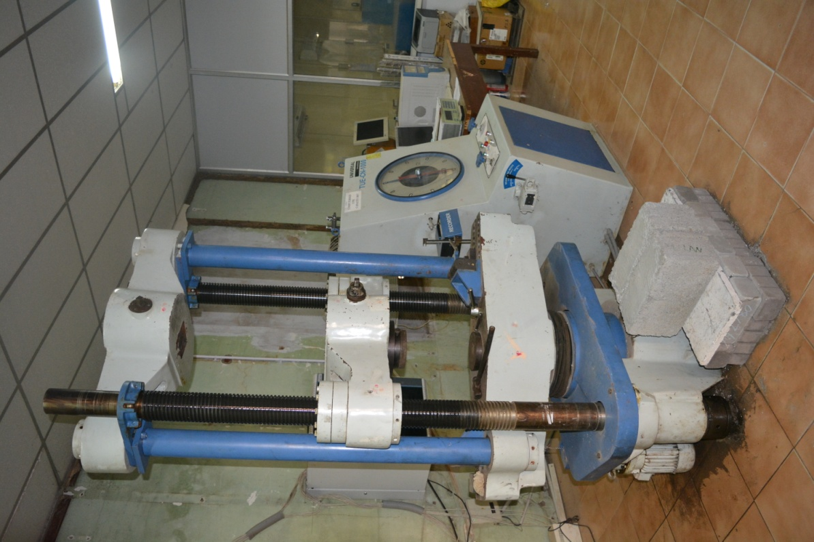

**COMPUTERISED UNIVERSAL TESTING MACHINE OF 100T CAPACITY**

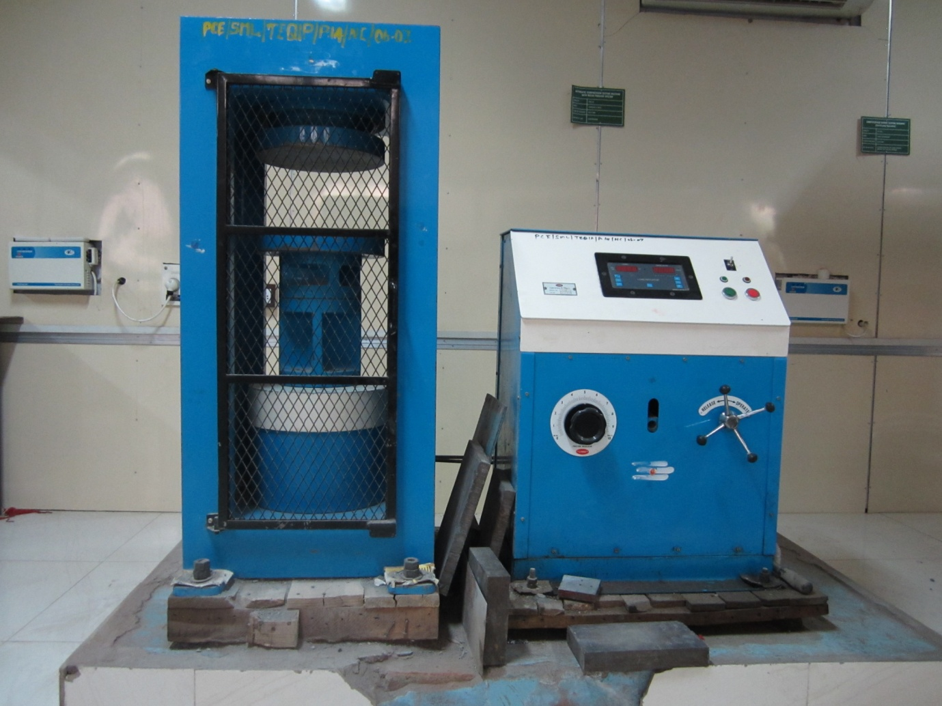

**DIGITAL COMPRESSION TESTING MACHINE OF 300T CAPACITY**

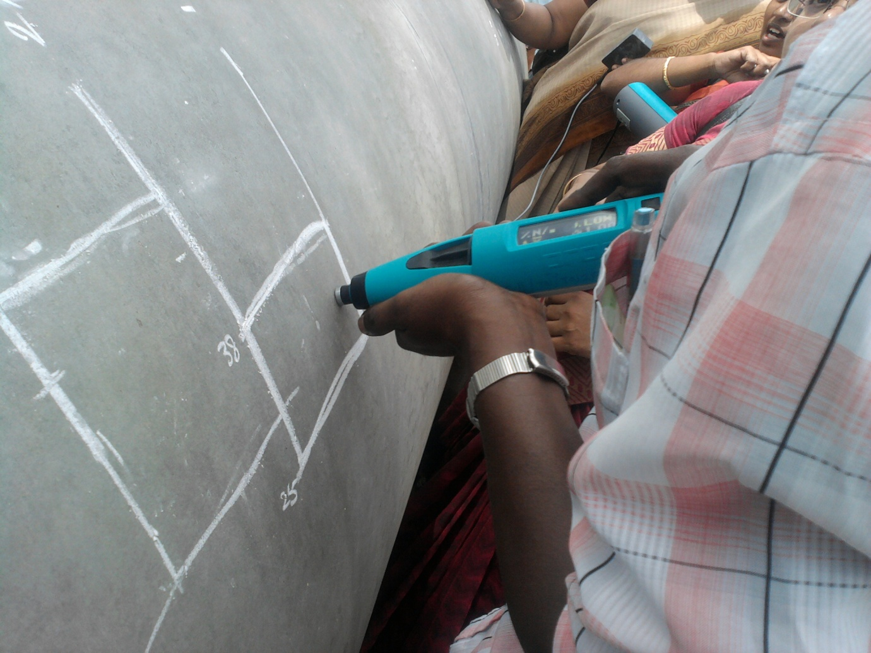

**REBOUND HAMMER**

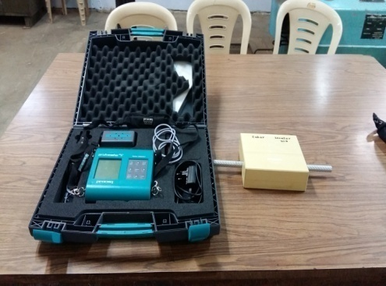

**REBAR LOCATOR**

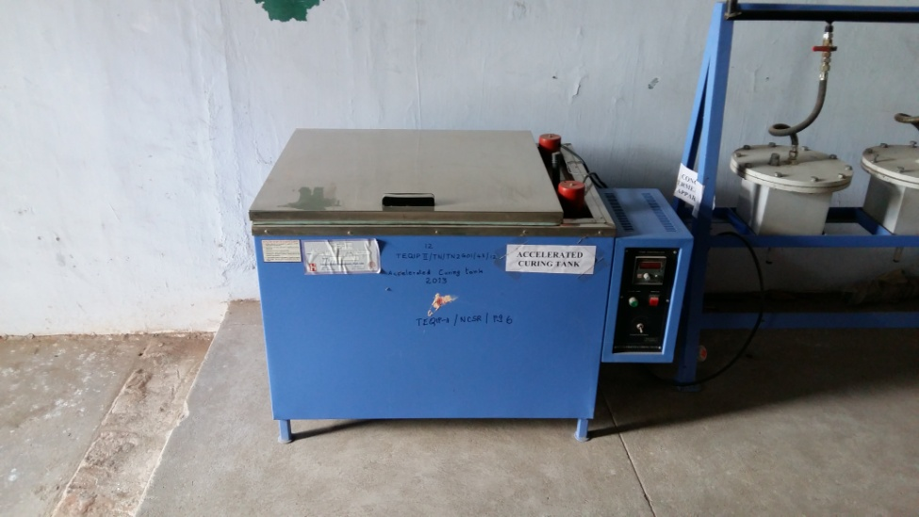

**ACCELERATED CURING TANK**

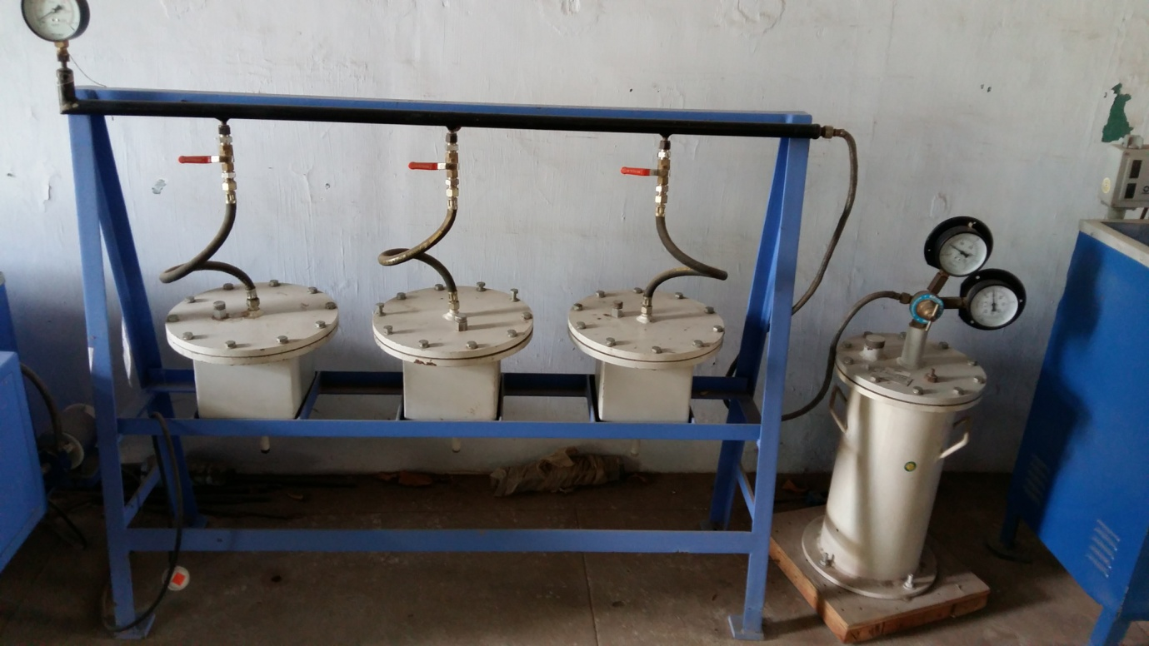

**PERMEABILITY APPARATUS**

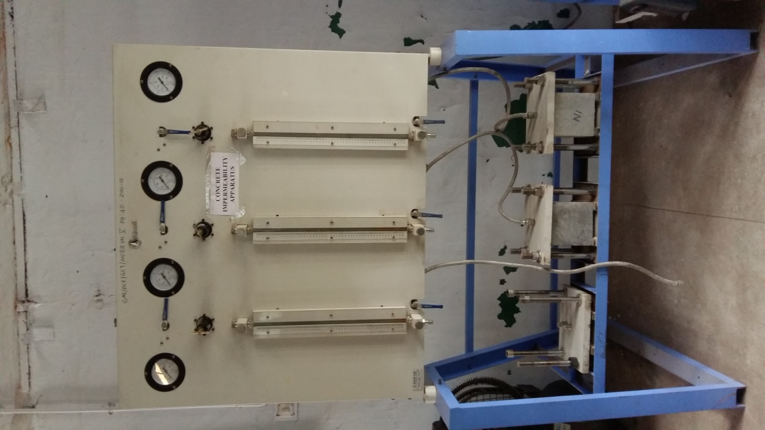

**IMPERMEABILITY APPARATUS**

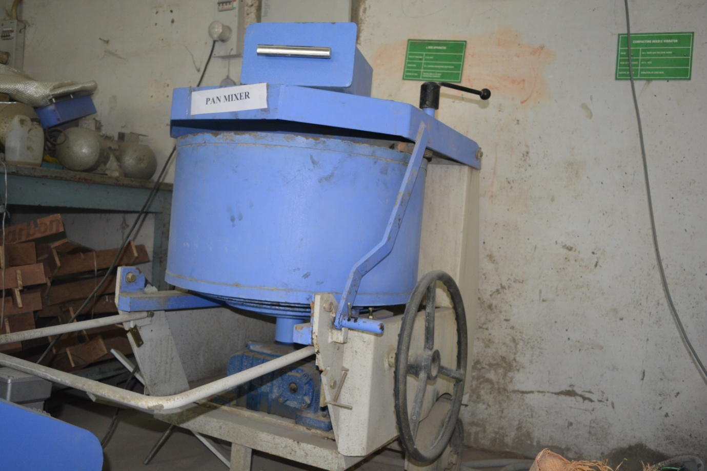

**PAN MIXER**

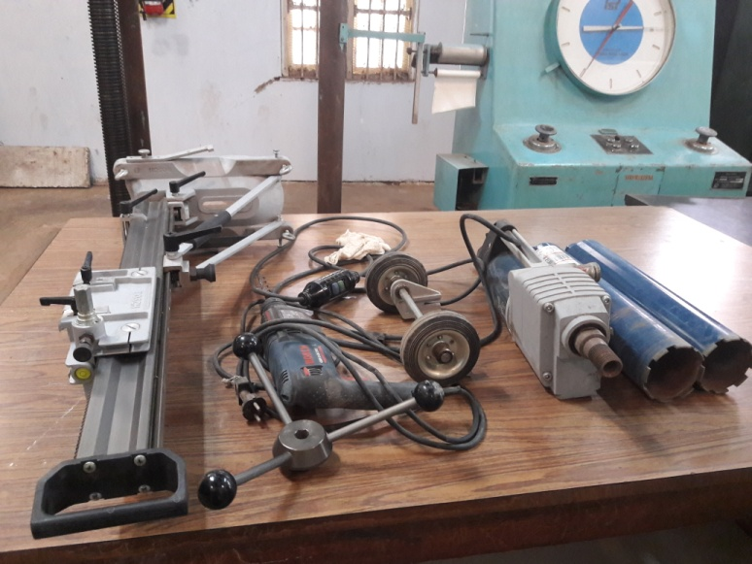

**CONCRETE CORE CUTTER**