**SMART ELECTRO-TLE:**

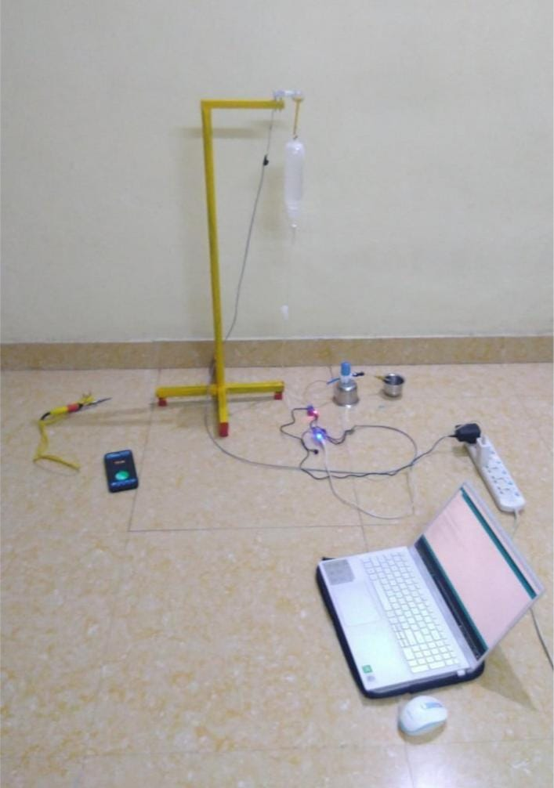**SPIRIT OF ENGINEERING-LESSONS FROM ADVERSITY**

Nurses were in their busy schedule during the covid pandemic, in order to reduce their work load **TEAM PHONEX** invented SMART **ELECTRO-TLE**

The idea was executed by VARSHINI, DEEPAN, NARENDRA VIMAL RAJ and SASIKUMAR (Production Engineers of the batch 2019-2023).

The solution won the **SECOND** prize at NAVYANTRA, a hardware hackathon with an open problem statement conducted by **INDIAN INSTITUTE OF TECHNOLOGY(ISM), DHANBAD** and won **THIRD** prize conducted by **PROJECTRO JEPPAAIR INSTITUTE , CHENNAI**.

**BAJA SAE India Event 2018**

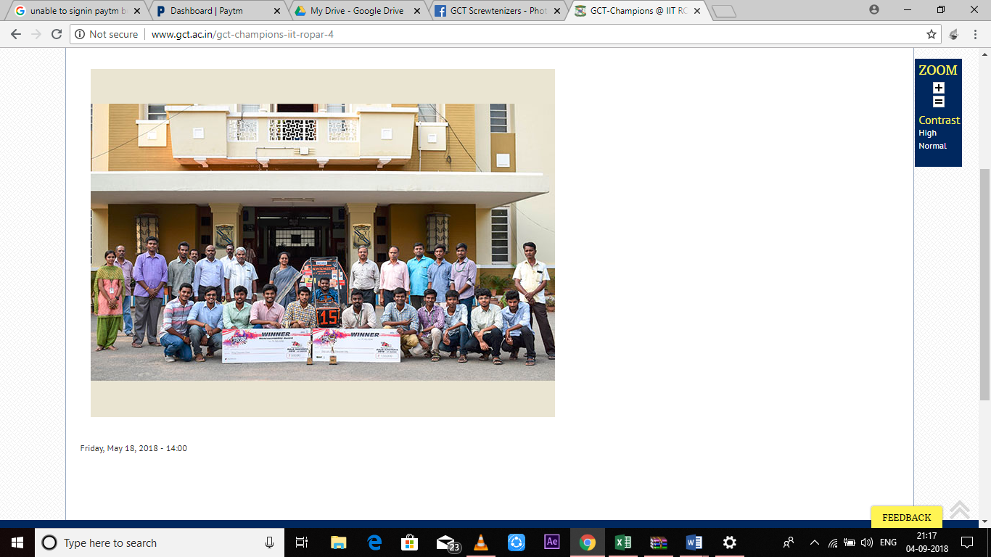 The BAJA Racing Team GCT Screwtenizers won the first prize in the Mahindra BAJA SAE India event held at IIT Roopar. The team secured cash prizes of worth Rs.2 Lakhs. The complete list of awards won are Overall Champions, First Place in Maneuverability, Second Place in Endurance, Second Place in Cost, Second Place in Sales, Second Place in Design, Third Place in Sled Pull. The team included students from various disciplines of engineering along with students from Department of Production Engineering.

**TRACTOR DESIGN COMPETITION 2018**

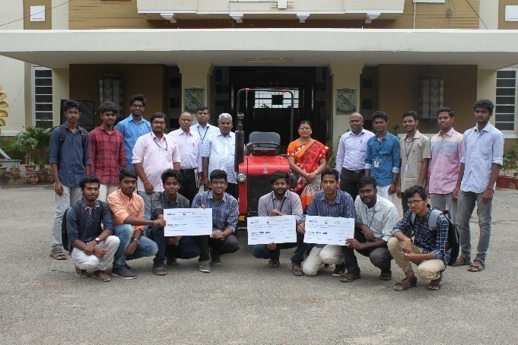 The Team ASPHALTERS for winning the first prize in the Tractor Design Competition by SAE India Southern section held at SRM University, Chennai. The team has managed to secure cash prizes of worth Rs 1,85,000/-. The complete list of awards won are Overall Champions, First Place in Best design, Third place in Best durability. The team included students from various disciplines of engineering along with students from Department of Production Engineering.

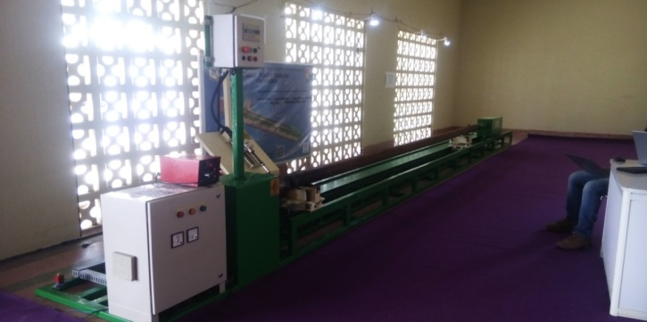**Automatic rigs rod pipe welding machine**

Fund Received:Rs. 3,44,689/-

Guide: Dr.S. Srinivasamoorthy

Student Members: T.Janartharaja, N.Arun Prakash and S.Jayaram

It has been awarded as best project by Dr.Mayilsamy Annadurai, Scientist, ISRO.

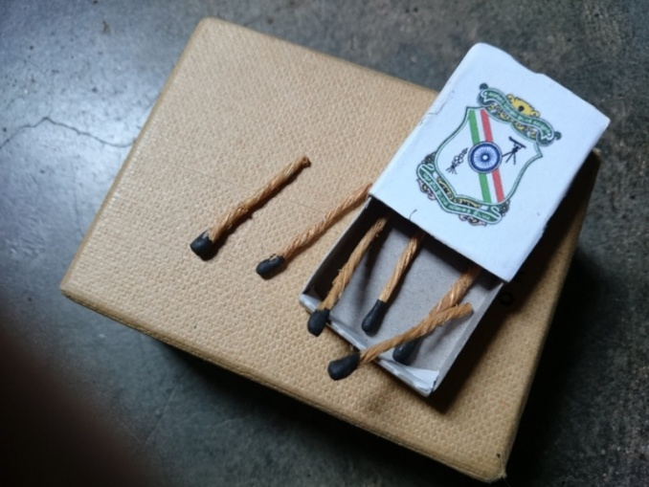**Coir Matchbox**

Fund Received:Rs. 16,545/-

Guide: Prof.A.Sasikumar

Student Members: Balakumaran.R.M, Jeeva.S, KavinRaj.K.S

The theme of the project is to replace wooden and paper matchsticks with coir to reduce cost and deforestation to an extent.

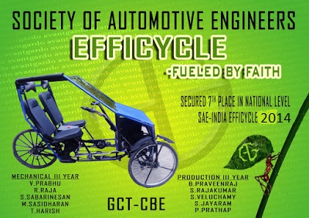**Avant Gardo Efficycle 2014**

Fund Received:Rs. 2,05,205/-

Guide: Dr.S. Gopi

AVANTGARDO is a hybrid three wheeler. The vehicle was made as a part of SAE-NIS-EFFICYCLE competition, 2014. This project has secured **7th place**in this national level competition amongst 100 teams conducted in Punjab.

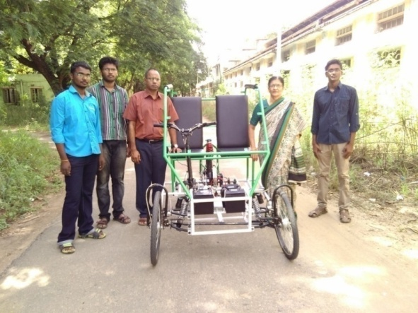  
**Efficycle 2015**

* This project was selected one among the best from the 100 teams that took part in the SAE-NIS-EFFICYCLE competition 2015.

**DESIGN OF SMALL SCALE PROTOTYPE OF STEP CLIMBING MACHINE** (By, Kishore R): https://www.youtube.com/watch?v=l6jKk1reATg

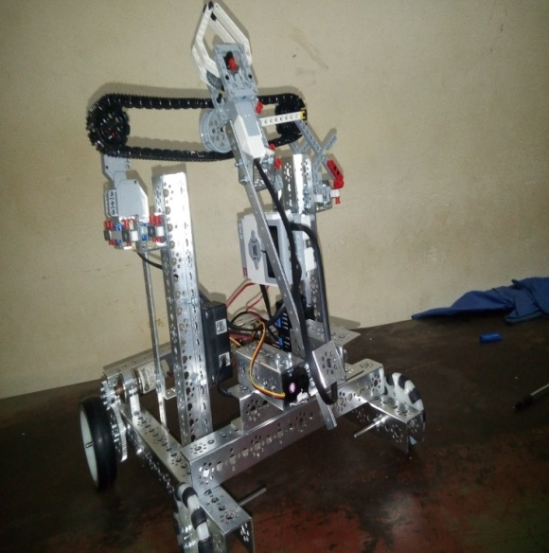**RESCUE ROBOT:**

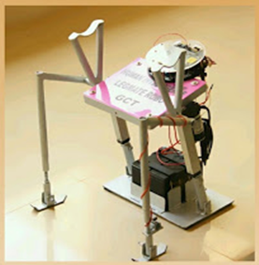(By, Vishnuhasan.S.A, Gowtham.C, Arunprakash.E, ArunKumar.S, Vinoth.C and Vijayaraghavan)   
The robot is selected for the CATERPILLAR FTC – competition.  
  
  
  
**LEGMATE ROBO, HUMAN INTELLIGENCE:**

Fund Received: Rs.18,000/-

Guide: Dr.S.Gopi

Student Members: G.Ilamparithy,B.Praveen Raj, S.RajaKumar and R.Rahul

It is a prototype of walk assistant robot for the physically disabled and secured third prize at the national level.

**LOW COST LAWN MOVER:**

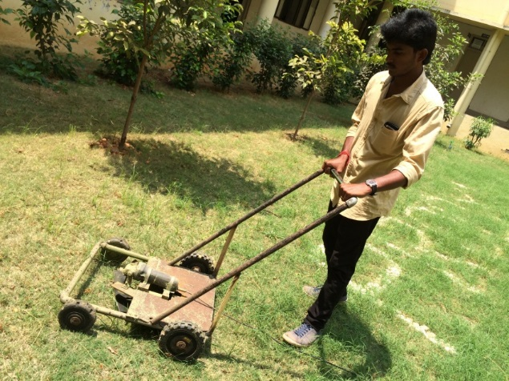(By, S.Naveen, V.Sasi Kumar, Rajamanikam, and M.Saravanakumar)

Fund recieved: Rs. 3,250

The power consumption is very low in comparative to the other lawn mower of the same capacity. The machine is being successfully used in the maintenance of the lawn in the Department of Production Engineering since September’15.

**INTERNATIONAL GOKART CHAMPIONSHIP – 2016 (SAE-LPU):**

The team AGONAZ from GCT Motorsports has participated and secured 2nd prize with a cash prize of Rs.1,10,000 which has held at Lovely Professional University at Ludhiana, Punjab. The complete list of awards includes overall runner-up, 2nd place in autocross. The team included students from various disciplines of engineering along with students from Department of Production Engineering.

**THERMAL TO ELECTRIC CONVERTER:**

Fund Received: Rs. 5,878/-

Guide: Dr.P.Ilamathi

Student members: Gunasekaran K, Abilash G, Ashok Kumar K B

The main purpose of the device is to charge the Laptops by using the principle of **“SEEBECK EFFECT”.**

**INTEGRATION OF LOWER HOUSING AND BASE IN 5HP OPEN WELL SUBMERSIBLE PUMP SET:**

Fund received: Rs.38,475/-

Student members: S.JAYARAM, S.KABILASH, S.S.SENTHILPRABU, M. RAJARATHINAM

**MULTI -ACTING RECIPROCATING PUMP USING DIAPHRAGM:**

Fund Received: Rs. 12,685/-

Guide: Dr.S.Gopi

Student members: M. Gautam, K. Gokul, S. Monish Raja, R. Rajesh

This project integrates the radial engine and the diaphragm pump for its usage to reduce the overall weight.

**SUCTION TYPE WINDMILL:**

Student members: E. ArunPrakash, B. KarthikDharan, S.A. SriramAnax) - A newly designed windmill which works on the principle of vertical windmill combined with a rotor-stator blade system (more likely a TURBOMOLECULAR PUMP).The project is selected one among the best two under theme MICRO INNOVATION in RESEARCH EXPO in IIT- MADRAS.

**CNC METHANE EXTRACTOR:**

Student members: Abdul Samath.M.R., B. AnkalaEswar

The project involves methane synthesis from engine outlets and reusing the synthesized methane. The project won 1st prize in Technical symposium of Bannari Amman Institute of Technology.

**ROAD CONDITION MONITORING AN IOT APPROACH**

Student members: Vishnu Priya.K, LogaPriya .P,Karthiyayeni.M,Eureka.S.

This project helps to replan the routes and reduce the traffic.

**MECHANICAL MOVING AGRO SPRAYER**

Student members: M. Saravana Kumar, N. Ponsankar , M. SadamHussain, C. Ranjith Kumar

This machine makes the spraying of pesticides semi-automatic.

**SIMPLE PLOUGHING AND SEED SOWING**

Fund Received:Rs. 40,000

Guide: Mr. N. Ajaymanikandan

Student members: A. Balasuriyan, N.K.R. Maghandiran, V. Arunkumar)

An SRF project that is helpful for the agricultural sector.