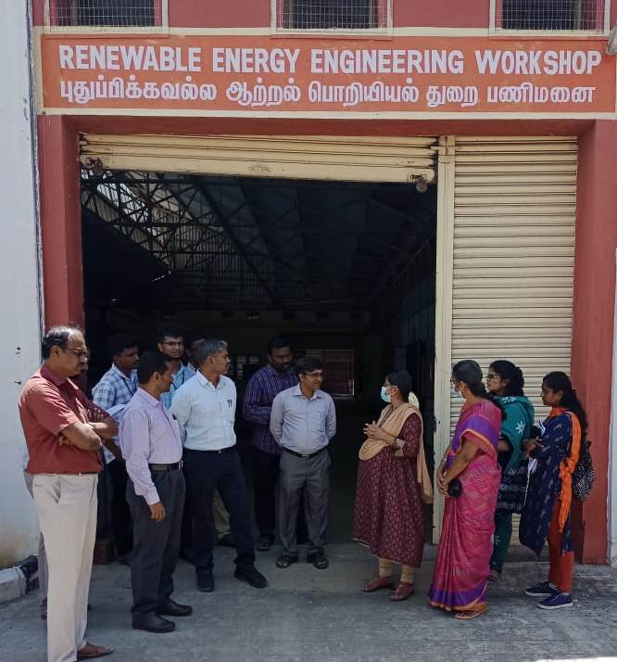

P.G - Engg Design and Manufacturing Engg students’ Industrial Visit at **Tami Nadu Agricultural University (TNAU)**, Coimbatore on 25.08.2022.

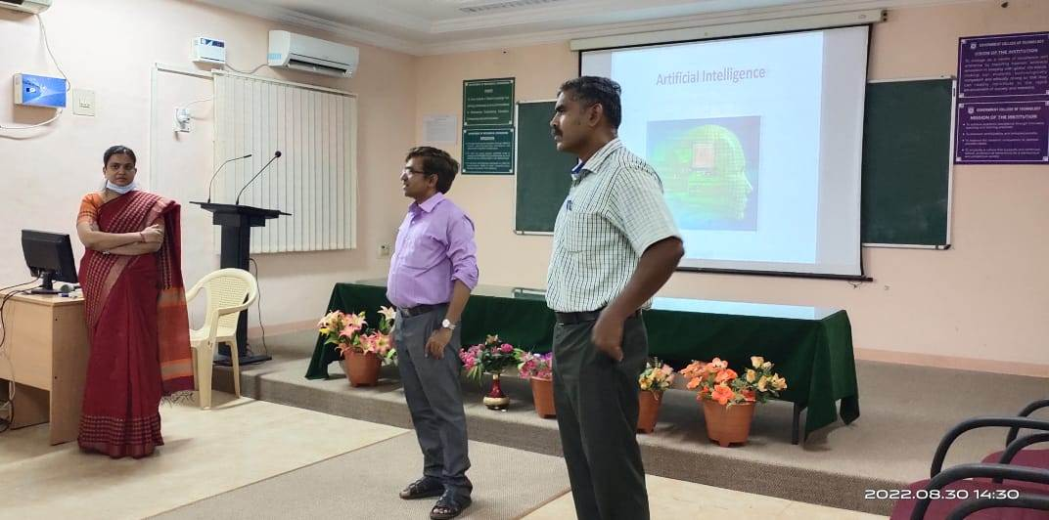

A Guest Lecture on **“Impacts of AI, ML & Cloud Computing for Manufacturing and Design Industries”** was delivered by **Dr.A.Meena Kowshalya,** Assistant Professor, Department of Computer Science Engineering, GCT, on 30.08.2022 for the benefits of P.G – Manufacturing and Engg Design students of GCT, Coimbatore.

.