**STUDENT’S ACHIEVEMENTS**

1. **Team PANAMERA** is a student team comprises 2019 Batch Final Year Mechanical Engineering students (S.Abitha, B.Balakumaran, T.Bharani, T.Bhuvan Bharath, S.Karthick, S.S.Moulii Daran) with mentor Dr.K.Ramesh had participated in national level competition known by Smart India hackathon -19 ( Hardware Edition) under project titled **"Low cost Vapour recovery system"** and among various teams all over the country, they were declared as **winners** under Complex category with a **cash prize of 1 lakh** at Krishna Institute of Engineering and Technology, Ghaziabad, Uttarpradesh and also they filed utility patent for their system.

<https://youtu.be/KkqtLgXdDG0>

<https://photos.app.goo.gl/mhLW4UBv4ovQtWQT9>

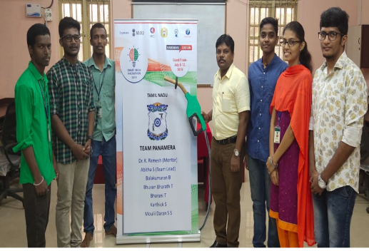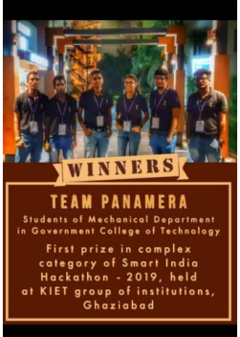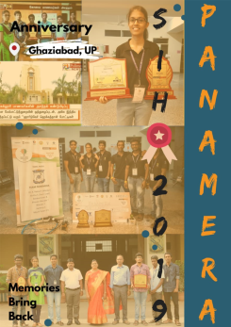

1. A team **SCREWTENIZERS** are doing marvellous work in designing vehicle and presenting it to national and international level contests. They achieved an overall ranking of 34 in an international event conducted by BAJA SAE. Notable achievements of Team **SCREWTENIZERS** are,

* Winner, 2018 edition at IIT Ropar
* Runner up, 2019 edition at Caterpillar INC
* Ranked 8, 2019 edition at IIT Ropar
* Ranked 21, 2020 edition at USA Arizona: <https://www.bajasae.net/res/EventResults.aspx?competitionid=58bac15a-15d9-4896-8916-9c62fc6beee2&eventkey=DESN>
* Ranked 34, 2021 edition at USA Arizona

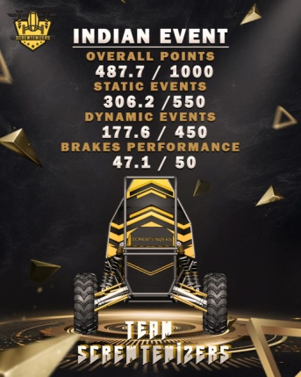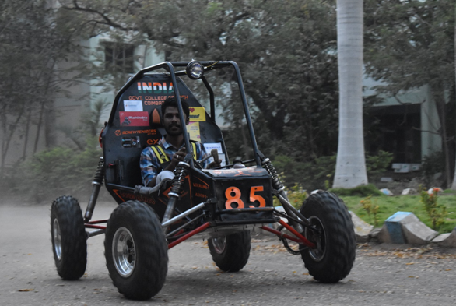

**GCT SCREWTENIZERS 2020 Car**

1. A Team of enthusiastic students **ASPHALTERS** who are involved in designing tractors. They are the winners of the 2018 and 2019 editions of the **SAEISS TRACTOR DESIGN** competition and runners of the 2020 edition.

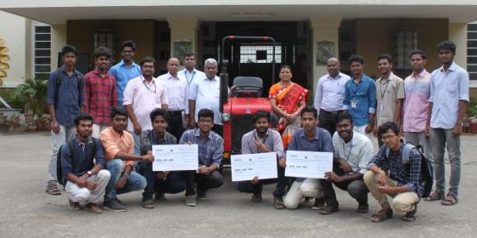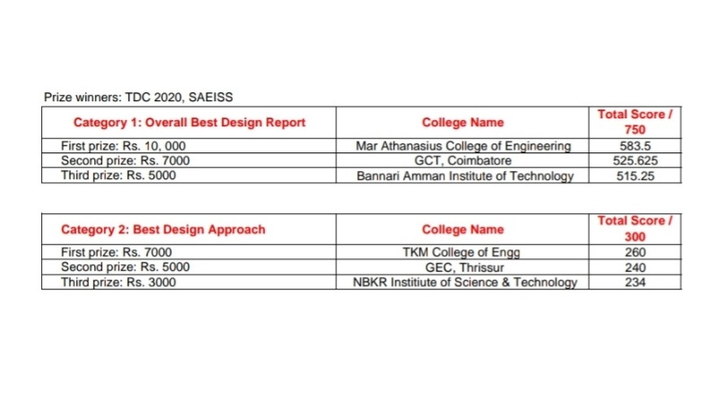

Winners in Tractor Design Competition 2018

1. A patent of **Micro Geometry optimization of spur gear for electric and hybrid vehicle applications** was published in IEEE.