**Student centered programme**

* A webinar on Awareness for Gate Exams By ACE Academy organized on 27nd July, 2023.

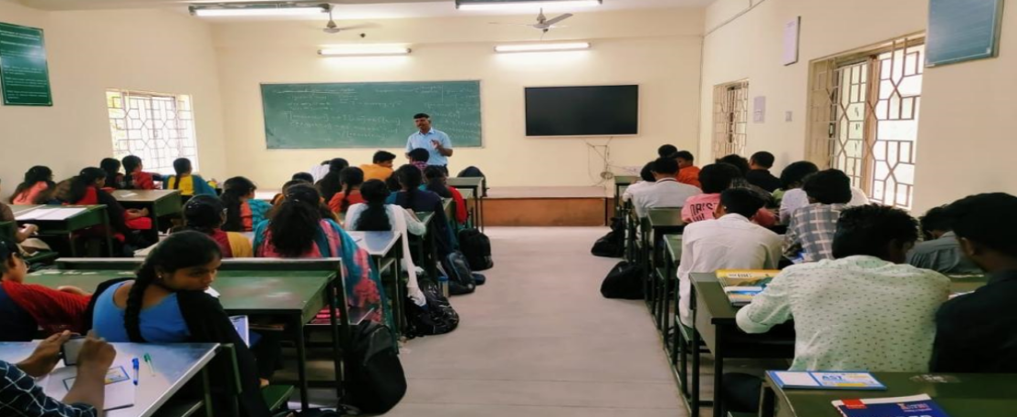

* A seminar Awareness for getting placed in companies by our super senior organized on 10th, August, 2023.

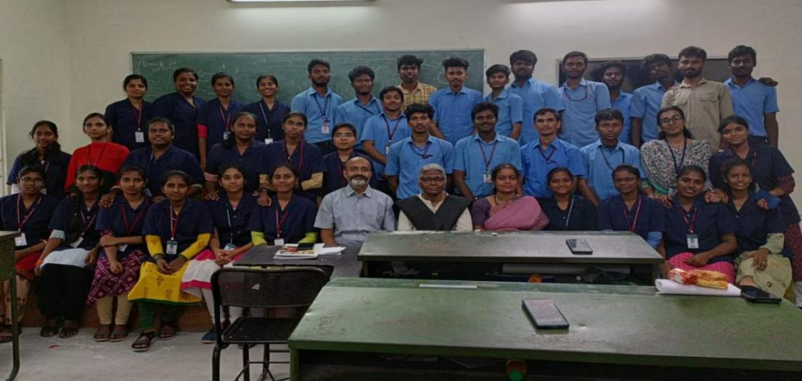

* A Seminar on Placement Tips by BOSCH &FLSmidthand Engineering on 24th August, 2023.

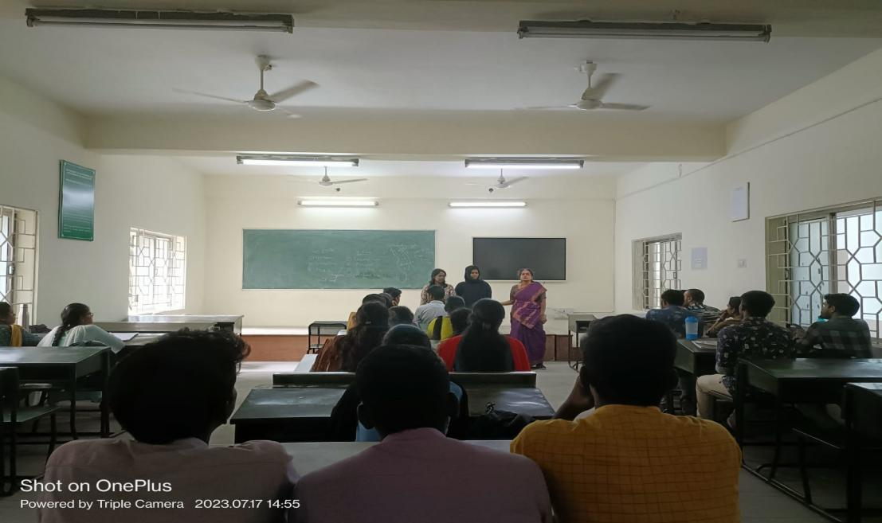

* A webinar on Engineers Day Celebration organized on 27nd July, 2023.

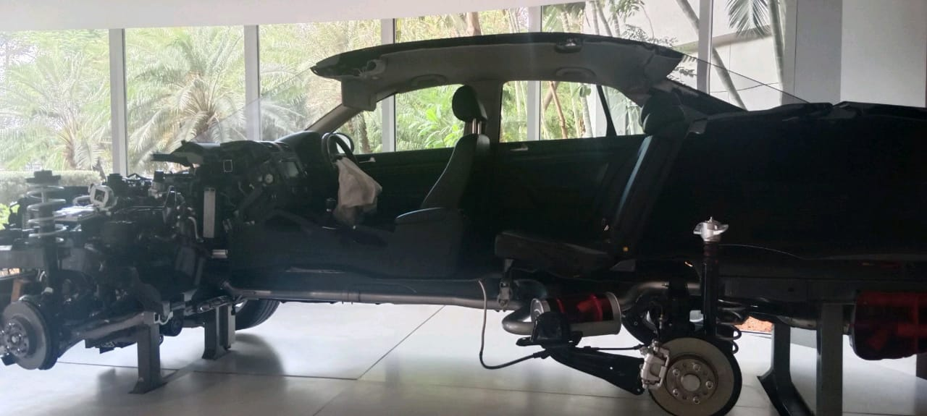

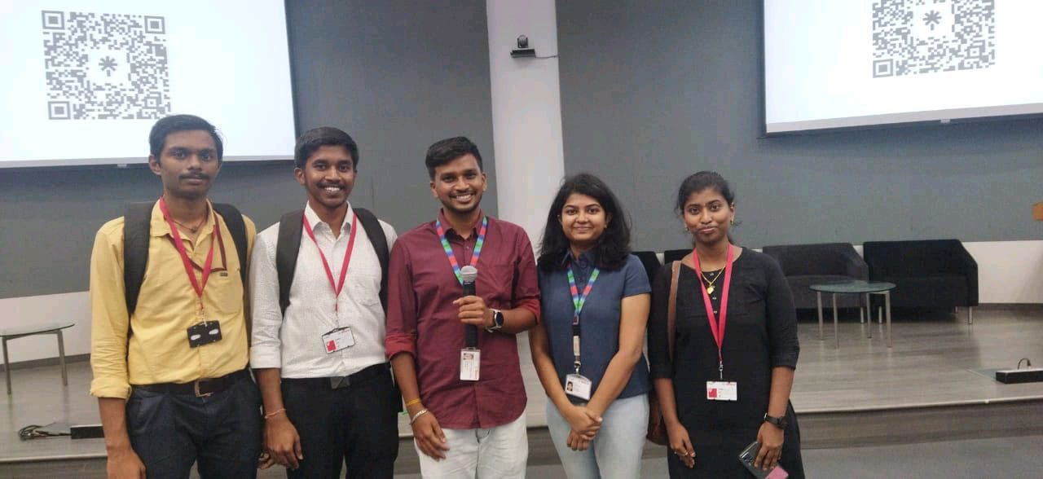

* A webinar on Insights on IT Placement organized on 21st,  September, 2023.

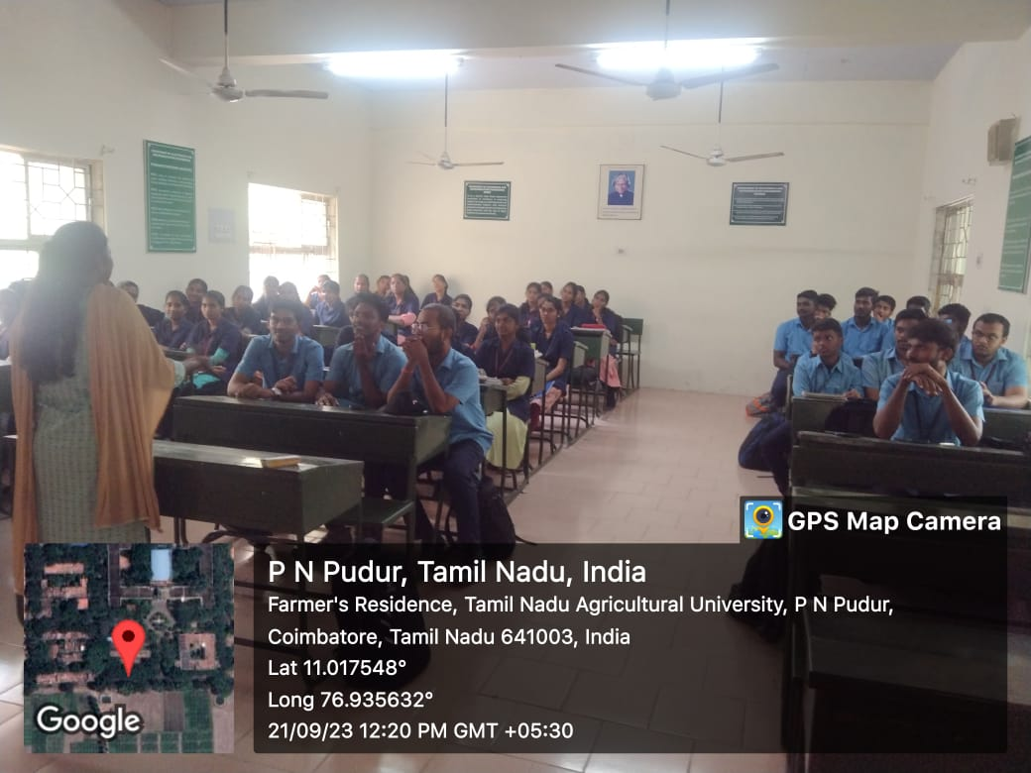

* One day Internal Hachathon for SIH 2023 organized on 25th September, 2023

.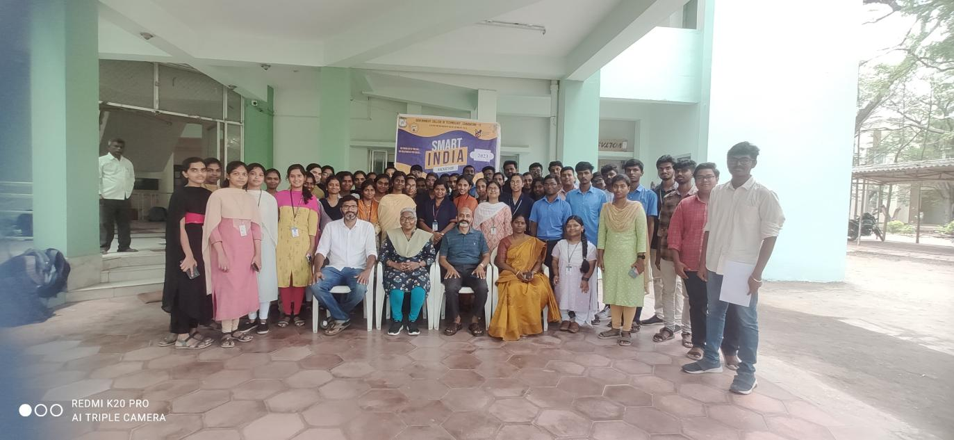

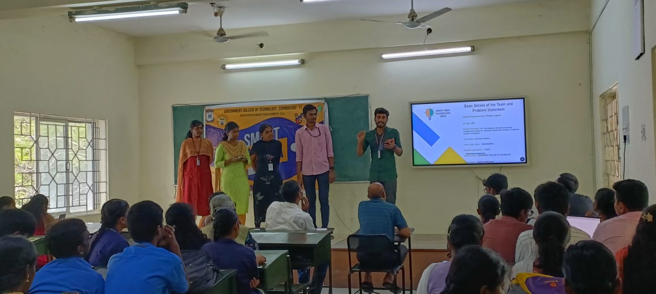

* One day Webinar on Introduction to Printed Circuit Boards organized on 26th October, 2023.
* One day Webinar on Opportunists for Higher Educations for Abroad by Edwise International organized on 6th February , 2024.
* One day Internal Hachathon for SIH 2024 organized on 9th September, 2024

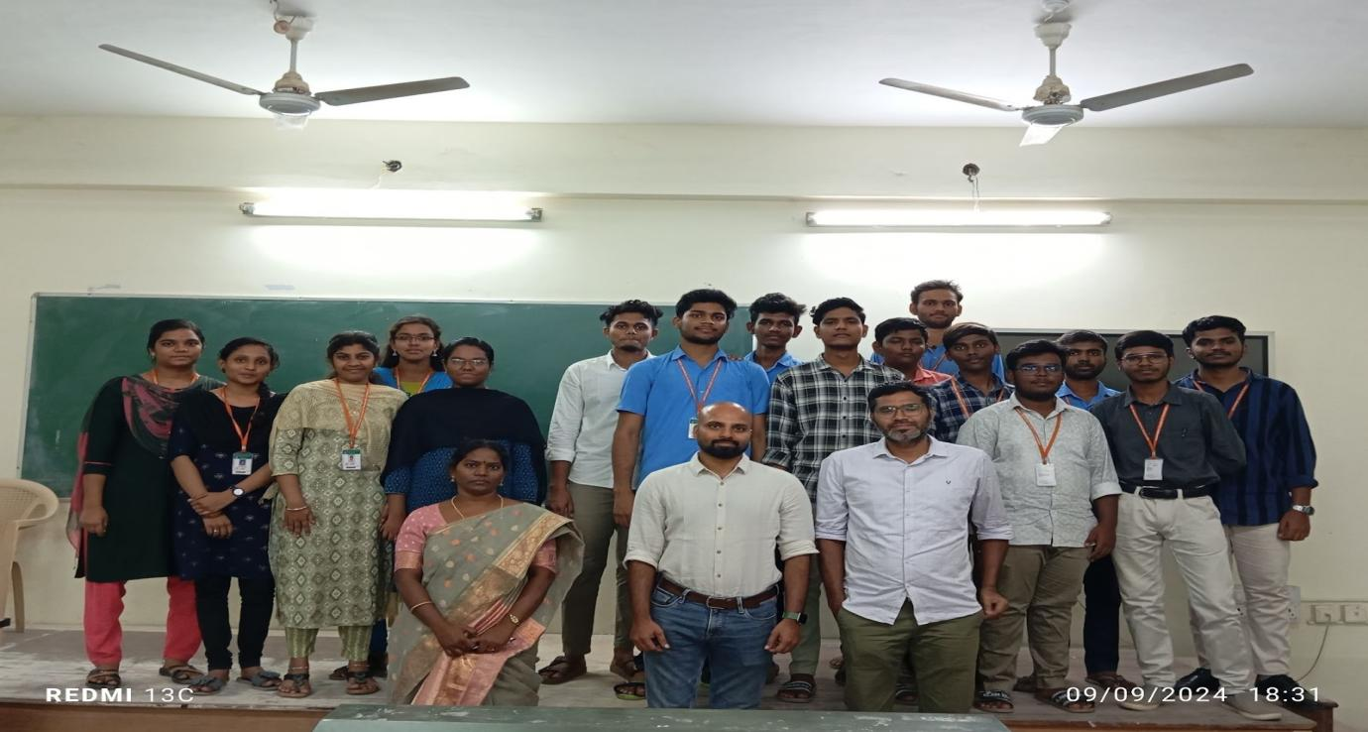

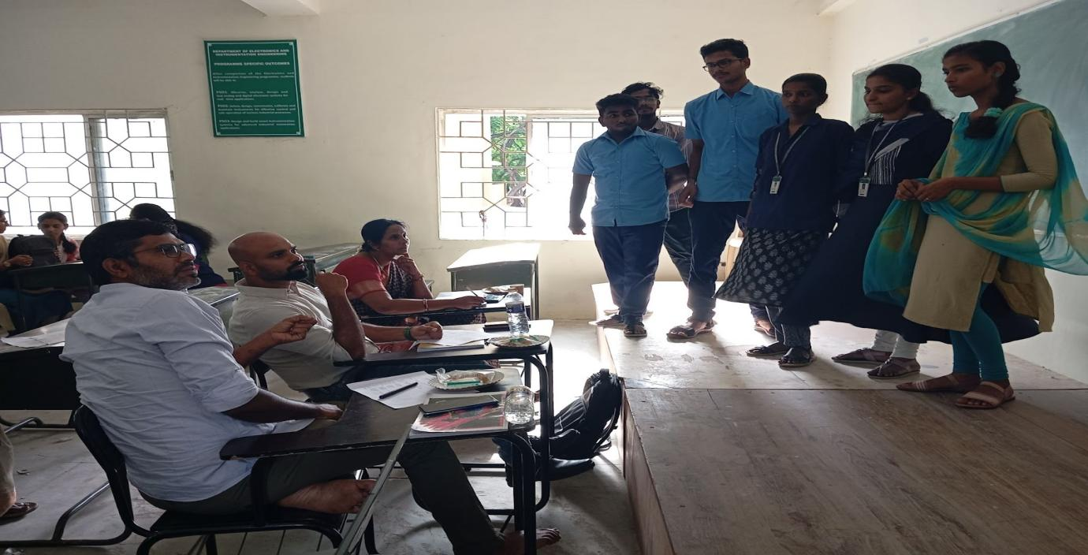

* One Day Induction Programme for First Year EIE Students organized on 12th September, 2024.

