GOVERNMENT COLLEGE OF TECHNOLOGY, COIMBATORE – 641 013
DEPARTMENT OF CIVIL ENGINEERING
Product development details (2018-2022)

Sl. No. | Faculty | Name of the product/ material | Year | Details of the product
1. | Dr.R.Thenmozhi  S. Janani | Cold – Formed Steel Sigma Purlins | 2020 | Cold Formed Steel sigma shaped purlins were tested for bending efficiency and best sigma profile in association with industry experts were arrived.  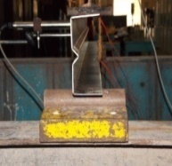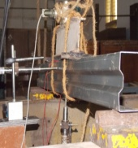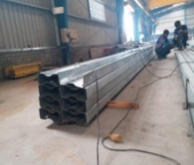
2. | Dr.R.Thenmozhi  N.Divyah | Stee – concrete composite columns made of sintered fly ash aggregate concrete | 2021 | Response of composite columns made of LWAC in uniaxial compression under static and cyclic loading conditions.  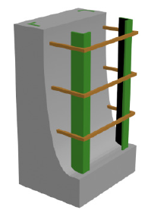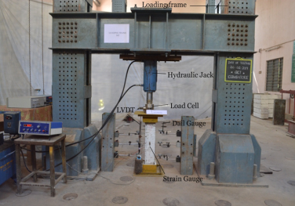
3. | Dr.J.Jeyanthi  R. Jayalakshmi | Polymer Nanocomposite | 2020 | 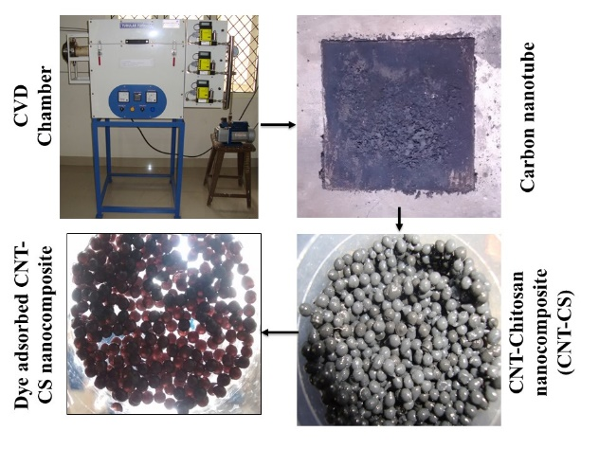  Carbon nanotube (CNT) prepared from Chemical vapour deposition system and dispersed in chitosan matrix to form CNT – chitosan nanocomposite and it was utilized was for the sequestration of binary mixture of textile dye effluent.
4. | Dr.J.Jeyanthi  B.Shoba | Membrane- Nano composite membrane | 2021 | Fabrication of polymericmembraneusing membrane casting unit for the treatment of industrial wastewater through ultrafiltration.  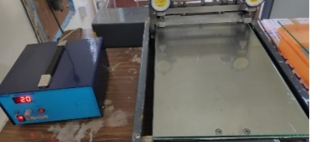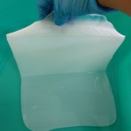
5. | Dr.J.Jeyanthi  M.Priya | Modified Cenosphereand Ceno-TiO₂/Al electrode | 2021 | Chitosan coated cenosphereand Ceno-TiO₂/Al electrode was prepared for the treatment of industrial wastewater through electrocoagulation  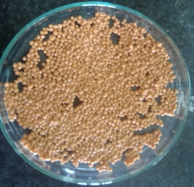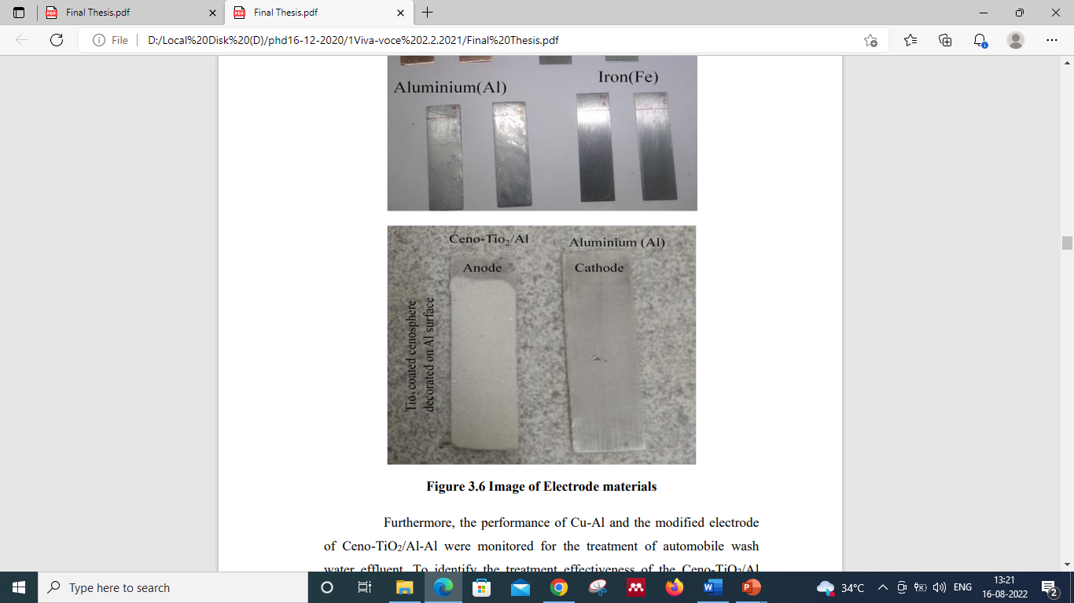
6. | Dr.S.Chithra  S.Praburanganathan | Fly ash bricks  with partial replacement of waste materials | 2021 | The structural responses of brick masonry elements constructed with fly ash bricks manufactured by incorporating various waste materials were evaluated
  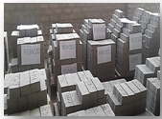 | 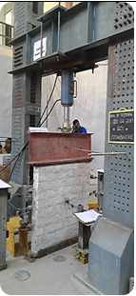
  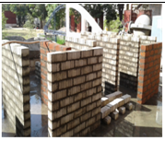
7. | Dr.R. Chithra  P. Mahakavi | Hybrid fiber reinforced  Self-compacting concrete using recycled waste materials | 2021 | Fresh, mechanical and durability properties of FS-RASCC with foundry sand and MS-RASCC with M-sand are evaluated. Also properties of optimized mix from FS-RASCC and MS - RASCC with hybrid steel fibers such as Hooked End and Crimped fibers are arrived.  